Partial Derivatives and Differentiability Worksheet

- Consider the surface given by the function .
- What is the equation of the curve which is the intersection between and ?

The curve is given by
This curve is represented by red curve in the picture below.
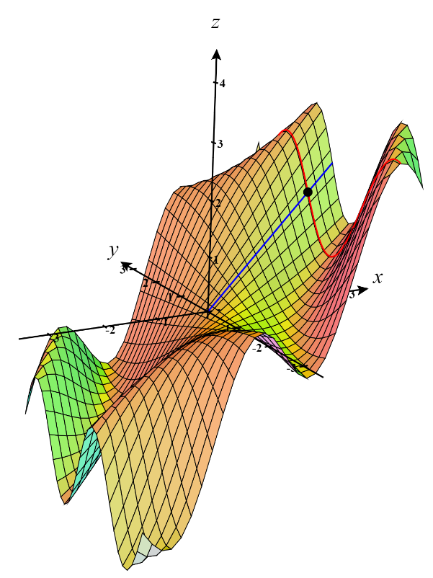

- Find the slope of the tangent line to the curve at the point .

We calculate that and so .
Therefore the slope of the tangent line to the curve at the point is .

- What is the equation of the curve which is the intersection between and ?

The curve is given by
This curve is represented by the blue curve in the picture below.

- Find the slope of the tangent line to the curve at the point .

We calculate that and so .
Therefore the slope of the tangent line to the curve at the point is .

- Determine the signs of the partial derivatives for the function f whose graph is shown below.
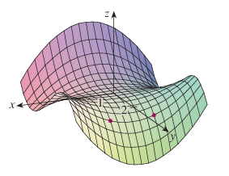
We look at the red dashed line in the top picture.
We see that the z-coordinate increases as x increases so .

We look at the solid red line in the top picture.
We see that the z-coordinate decreases as y increases so .

We look at the blue dashed line in the top picture.
We see that the z-coordinate decreases as x increases so .

We look at the solid blue line in the top picture.
We see that the z-coordinate decreases as x increases so .

We look at the blue dashed curve in the bottom picture.
We see that the curve at this point is concave up and so .

We look here at the solid blue curve in the bottom picture.
We see that the curve at this point is concave down and so.

We look at the red dashed curve and consider the tangent line with respect to x at this point. We see that here . Now, represents how much changes as we move in the positive y direction. We see that if we move slightly over (say to a point like moving down the solid red curve) the slope of the tangent line (with respect to x) will be steeper and therefore is increasing with respect to y. Therefore, .

We look at the blue solid curve and consider the tangent line with respect to y at this point. We see that here . Now, represents how much changes as we move in the positive x direction. We see that if we move slightly over (say to a point like moving down the dash blue curve) the slope of the tangent line (with respect to y) will be steeper (but in a negative direction) and therefore is decreasing with respect to x. Therefore, .

- Find all the first partial derivatives of the function.

- (Hint: Use the Fundamental Theorem of Calculus).

To find we first rewrite .
Therefore, .

- Find all the second partial derivatives of .

We see that
Therefore,

- Find all second partial derivatives of .

We see that
Therefore,

- Find given that .

First we note that .
Then we calculate that

- Find the value of at the point if the equation defines z as a function of the two independent variables x and y and the partial derivative exists.

We begin by calculating the partial derivative of both sides with respect to x, while treating y as a constant and z as a mystery function of x and y.

Therefore,
- Suppose that is determined implicitly by the equation . Find and its value at the point .

We begin by calculating the partial derivative of both sides with respect to y, while treating x as a constant and z as a mystery function of x and y.

Therefore, know that

- Consider the equation . Find .

- Suppose that for the function we know that and are both differentiable at . Prove that .

Since we know that and are both differentiable at we can say that they are both continuous at . However, we know from section 3.3 that if the mixed partials of a function are continuous at a point they must be equal at that point.

Therefore, we can conclude that .

